**Institute of Technology Tralee**

**BSc. in Computing with Specialism (Group 2) - Year 1**

**Continuous Assessment #1**

**Date: 21/10/13**

**Time: 1 – 3 p.m.**

**Introduction to Programming**

**Instructions:** Attempt the following question. You should use the JCreator IDE for coding. When you are finished you must print out your code for correction.

**________________________________________________________**

**Q1.**

In chemistry, the ideal gas law can be expressed using the following formula:

where

* V is the volume of the gas
* n is the number of moles of the gas (declare this as a **whole number**)
* R is the universal gas constant, whose value should be set to 8.3145 in your program (create a constant for R in your program)
* T is the temperature of the gas in degrees Kelvin
* P is the pressure of the gas

Write a Java program that calculates the volume of gas in a specific situation.

The program should request the user to supply values for n, T and P and then use the formula above to calculate the corresponding volume.

The volume should then be displayed correct to **3 decimal places**.

In reality, the temperature of the gas must be some positive value (i.e. strictly **greater than zero**) and your program should test to make sure that only positive numbers are accepted for the temperature. If the user does enter a negative number (or zero) for the temperature, the program should immediately issue an appropriate error message and then quit execution, without requesting any further information or performing any other calculations.

Using the test values as indicated in the screen shots below, the program should give you **exactly** the following output when it runs, including banners, blank lines, units etc.

Note when displaying the **cube character** for the units, it has an ASCII code value of 252.

Also note that there will be a few marks awarded for the use of **meaningful variable names**, having a  **single and multi-line comment at the top of the program** and for **proper indentation** in the coding of the program.

**Sample Screen Shots**

**The user enters an invalid temperature value here**

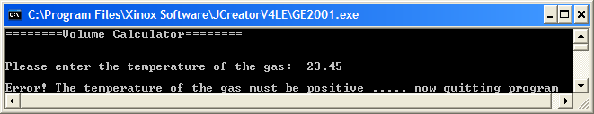

**The user enters a valid temperature value here**

